Process Document: Adding "Distribution Center - Aurora" to Impacted Departments in Windchill NA (Quality Plan Section)

Process Document: Adding "Distribution Center - Aurora" to Impacted Departments in Windchill NA (Quality Plan Section) 1
1. Purpose 1
2. Prerequisites 1
Step 1: Create / Utilize Jira Request 1
Step 2: Implement Change in QA Environment 1
Step 4: Validation by AMS team 2
Step 6: User Validation on QA 4
Step 7: Approval from Ravi 4
Step 8: Deploy Change to Production 4
Step 9: Export Type Definition After Production Deployment 4

1. Purpose
This document outlines the steps required to add “Distribution Center - Aurora” to the Impacted Departments dropdown in the Quality Plan section of Windchill NA, including the validation, approvals, and production deployment.

2. Prerequisites
• Access to Jira to manage the enhancement request.
• Access to Windchill QA and Windchill Production environments.
• Access to export Type Definitions from Production after deployment.

Step 1: Create / Utilize Jira Request
A Jira ticket is required to proceed with the change.
Jira Ticket: https://fresenius.atlassian.net/browse/WCENHANCE-198
If the team does not have access to Jira, submit a request for Jira access for all required team members.

Step 2: Implement Change in QA Environment
Update the Impacted Departments list under Quality Plan in the Windchill QA environment.
Add the new entry: “Distribution Center - Aurora” and notify the user for validation.
Add to Department List enumeration:
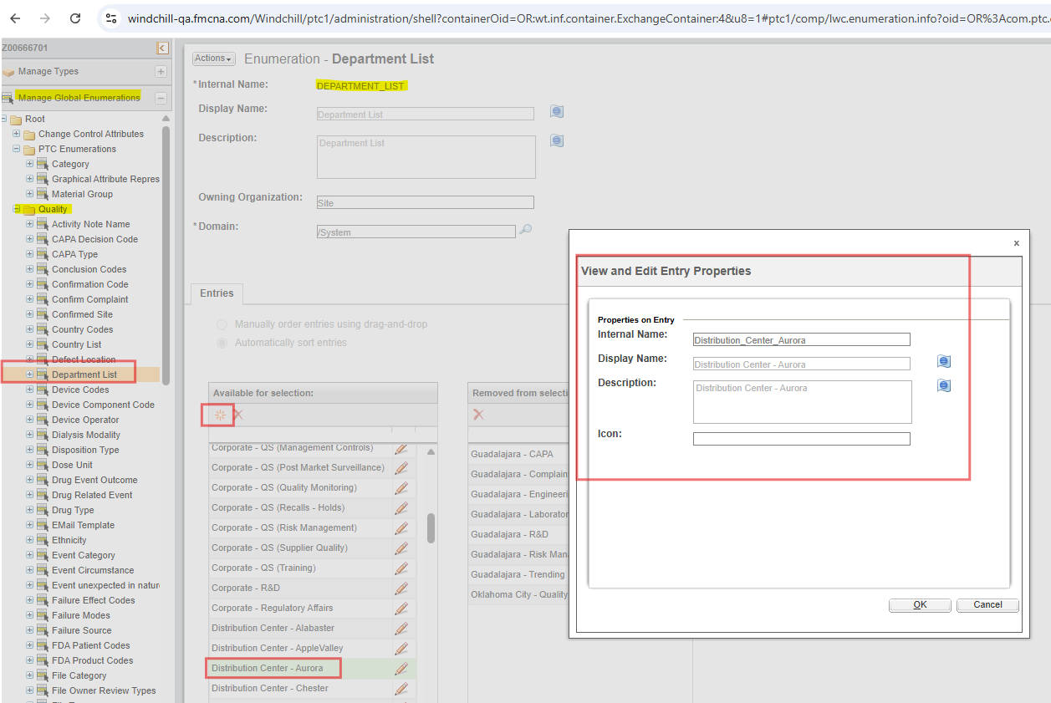
Update Legal Value List on CAPA Request:
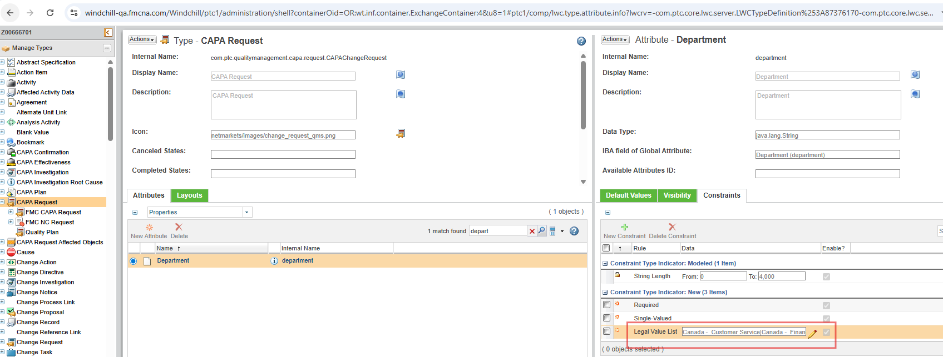

Step 4: Validation by AMS team
Use the below search criteria, if you don’t find a Quality Plan object
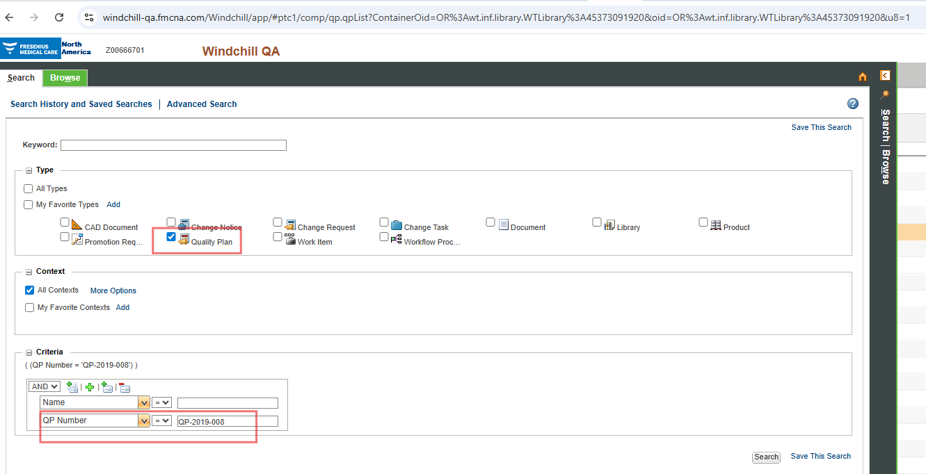
Click on Quality Plan
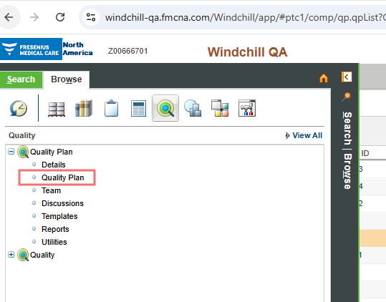
Click on New Quality Plan
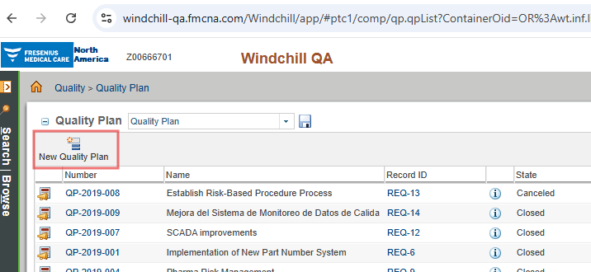
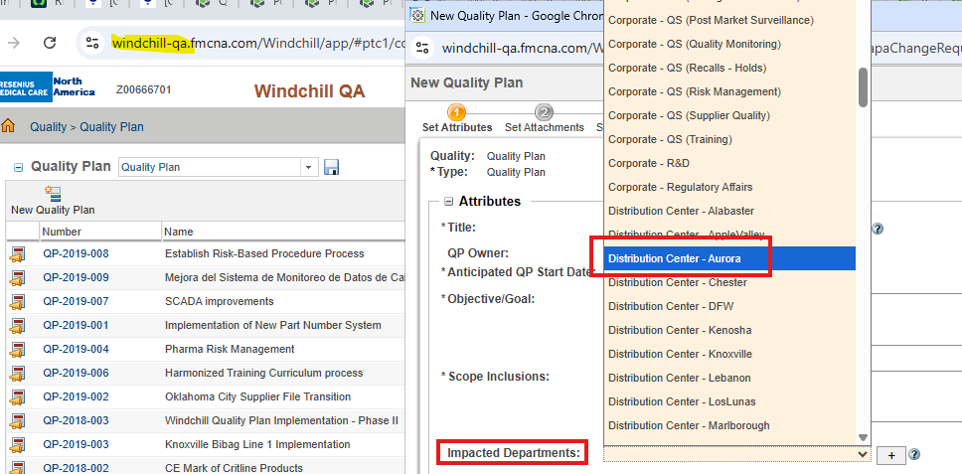

Step 6: User Validation on QA
Request the business user to validate the change in QA and capture confirmation.

Step 7: Approval from Ravi
Send an email to Ravi requesting approval to proceed with Production deployment along with Jira link, QA validation confirmation, and screenshots (optional).

Step 8: Deploy Change to Production
Implement the same configuration updates in Windchill Production after approvals.

Step 9: Export Type Definition After Production Deployment
Export the relevant Type Definition XML after deployment.
Reference: https://dev.azure.com/FreseniusMedicalCare/PDM%20-%20Product%20Data%20Management/_git/FMC_Windchill_NA_SCM?path=/loadFiles/ext/fmcna/part/PartType/PartTypeDefinitionExporter.xml

